1. Agenda:
   1. How to Simulator Fault Responses (Network Error) using WireMock.
2. 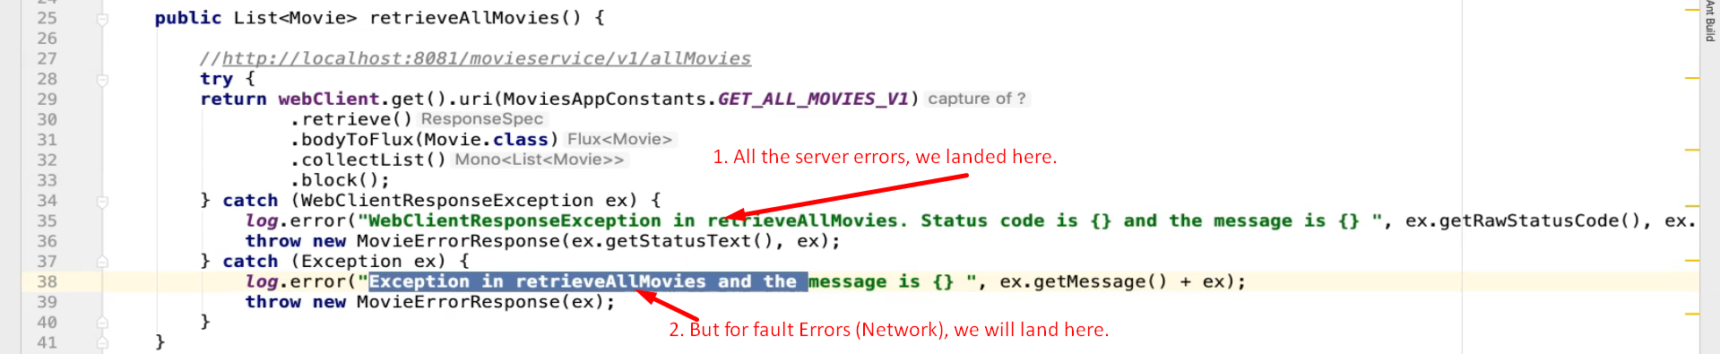
3. 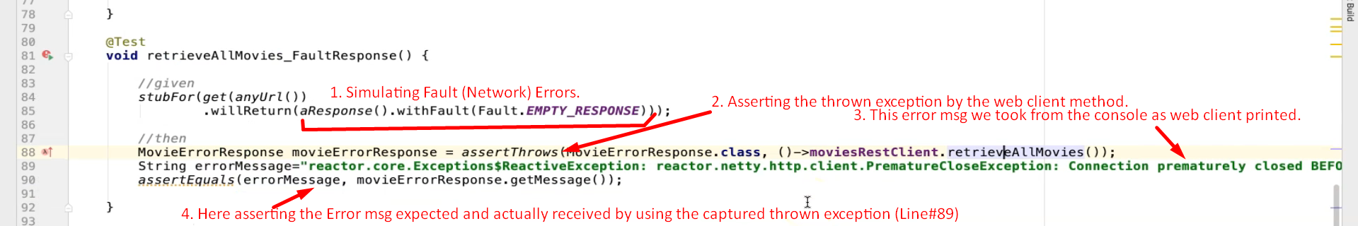
4. Let’s do something more.